ASSIGNMENT : 2
1.
Create a custom JSON-based policy in AWS IAM that allows read-only access to all objects in an S3 bucket named 'my-music-playlists', and attach this policy to a new user called 'playlistViewer'.
ANS :
Steps :
- Logged in to the AWS Management Console and opened the IAM service.
- Navigated to Policies and clicked Create policy.
- Selected the JSON tab and entered a custom policy with s3:GetObject permission for all objects in the my-music-playlists S3 bucket.
- Named the policy PlaylistViewerReadOnlyPolicy and created the policy.
- Navigated to IAM → Users and clicked Create user.
- Created a new IAM user named playlistViewer.
- Selected Attach policies directly and attached PlaylistViewerReadOnlyPolicy to the user.
- Reviewed the configuration and created the user.
- Verified that PlaylistViewerReadOnlyPolicy was successfully attached to the playlistViewer user.
Screenshot : Custom JSON-based IAM policy granting read-only access to all objects in the my-music-playlists S3 bucket.
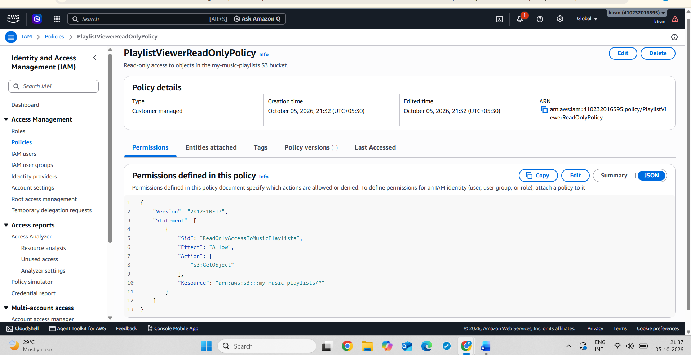
Screenshot : Successfully created the PlaylistViewerReadOnlyPolicy IAM policy.
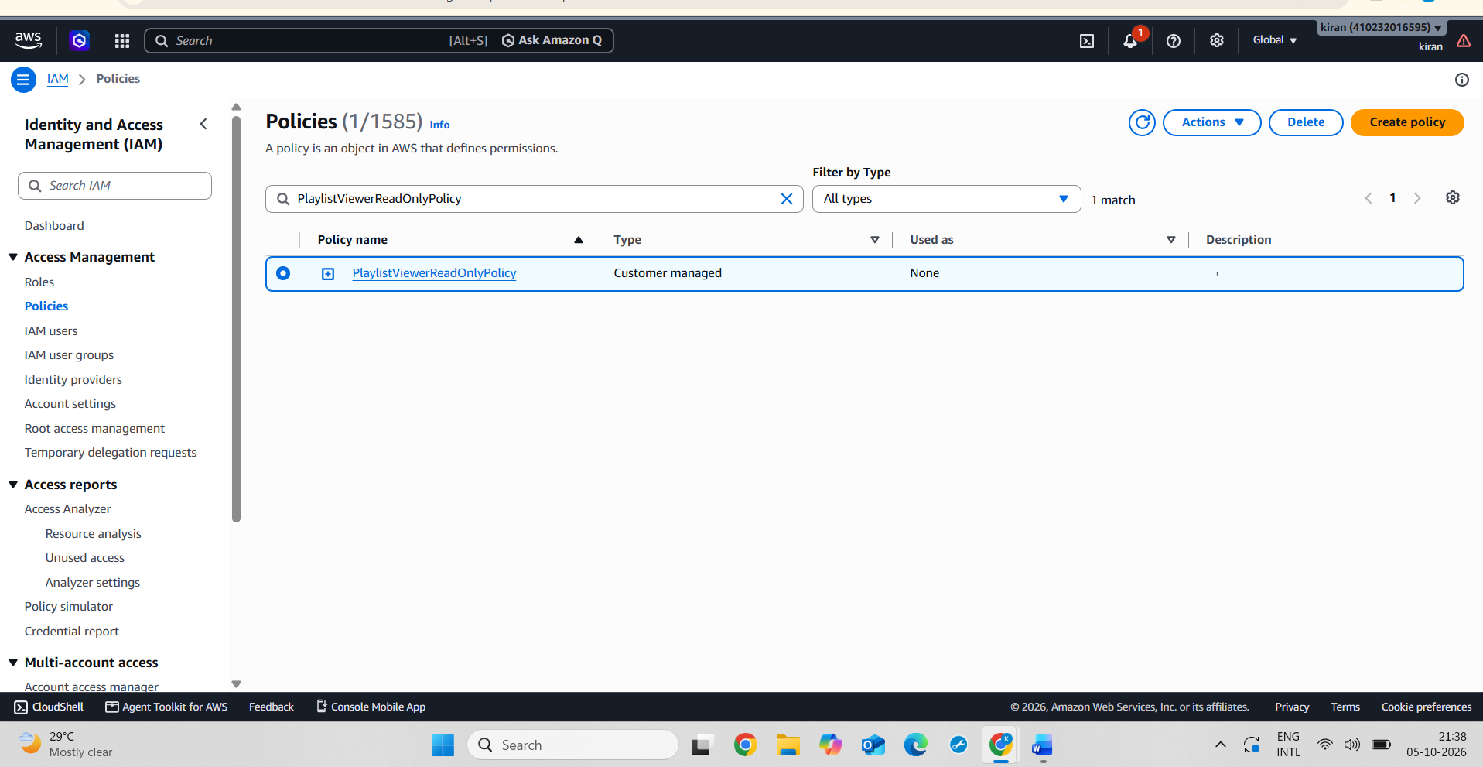
Screenshot : PlaylistViewerReadOnlyPolicy successfully attached to the playlistViewer IAM user.
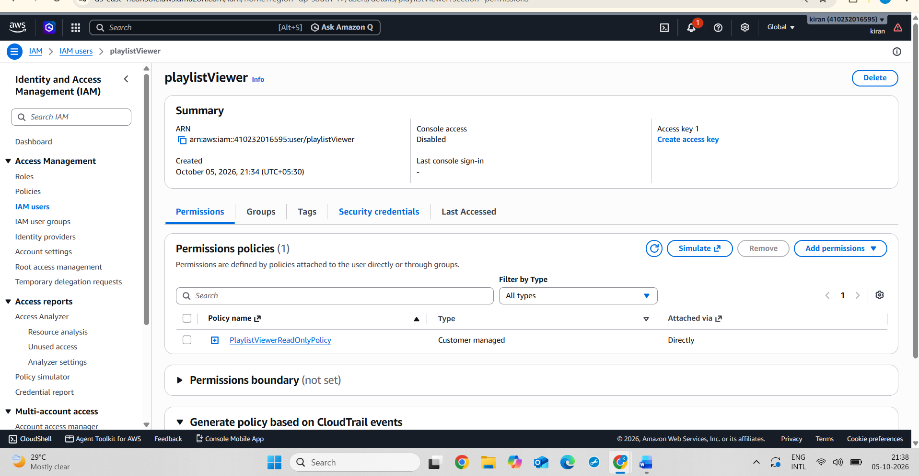
2.
Write an inline policy in JSON that allows a user to start and stop EC2 instances only with the tag Environment:Dev, and attach it directly to an existing IAM user named 'devOpsIntern'.<br><br><em><strong>Hint:</strong> Use 'Condition' in your policy to filter by tag.</em>
ANS :
Steps :
- Logged in to the AWS Management Console and opened the IAM service.
- Navigated to IAM → Users and created the IAM user devOpsIntern because the user did not already exist.
- Opened the devOpsIntern user and selected the Permissions tab.
- Clicked Add permissions → Create inline policy.
- Selected the JSON tab and entered a policy allowing ec2:StartInstances and ec2:StopInstances.
- Added a Condition using the Environment=Dev resource tag so that the permissions apply only to EC2 instances tagged Environment: Dev.
- Named the inline policy DevEC2StartStopPolicy and created it.
- Verified that DevEC2StartStopPolicy was displayed under the Inline policies section of the devOpsIntern user.
Screenshot : Custom JSON inline policy allowing start and stop operations only on EC2 instances tagged Environment=Dev.
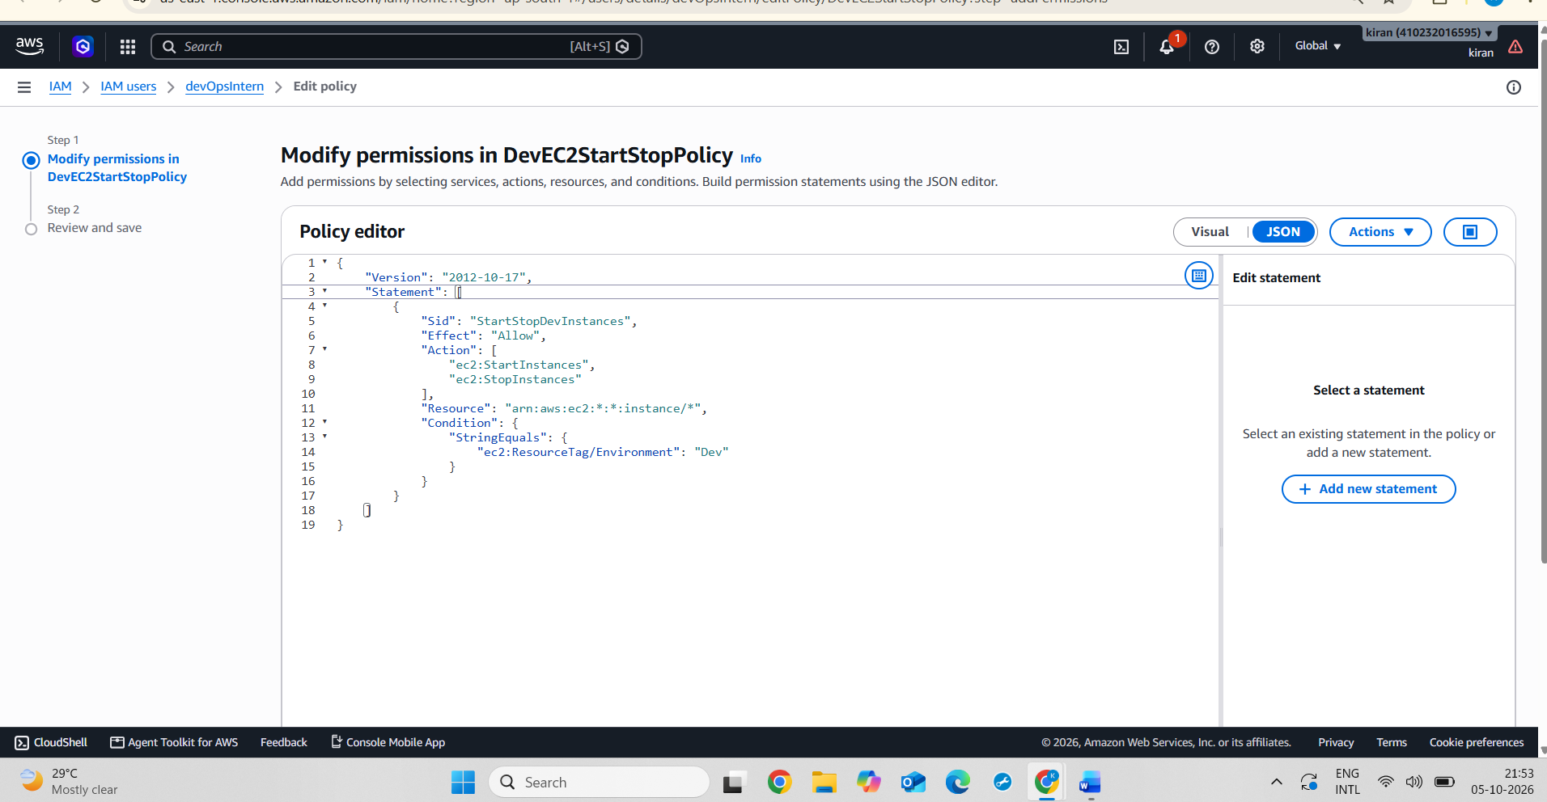
Screenshot : DevEC2StartStopPolicy successfully attached as an inline policy to the devOpsIntern IAM user.
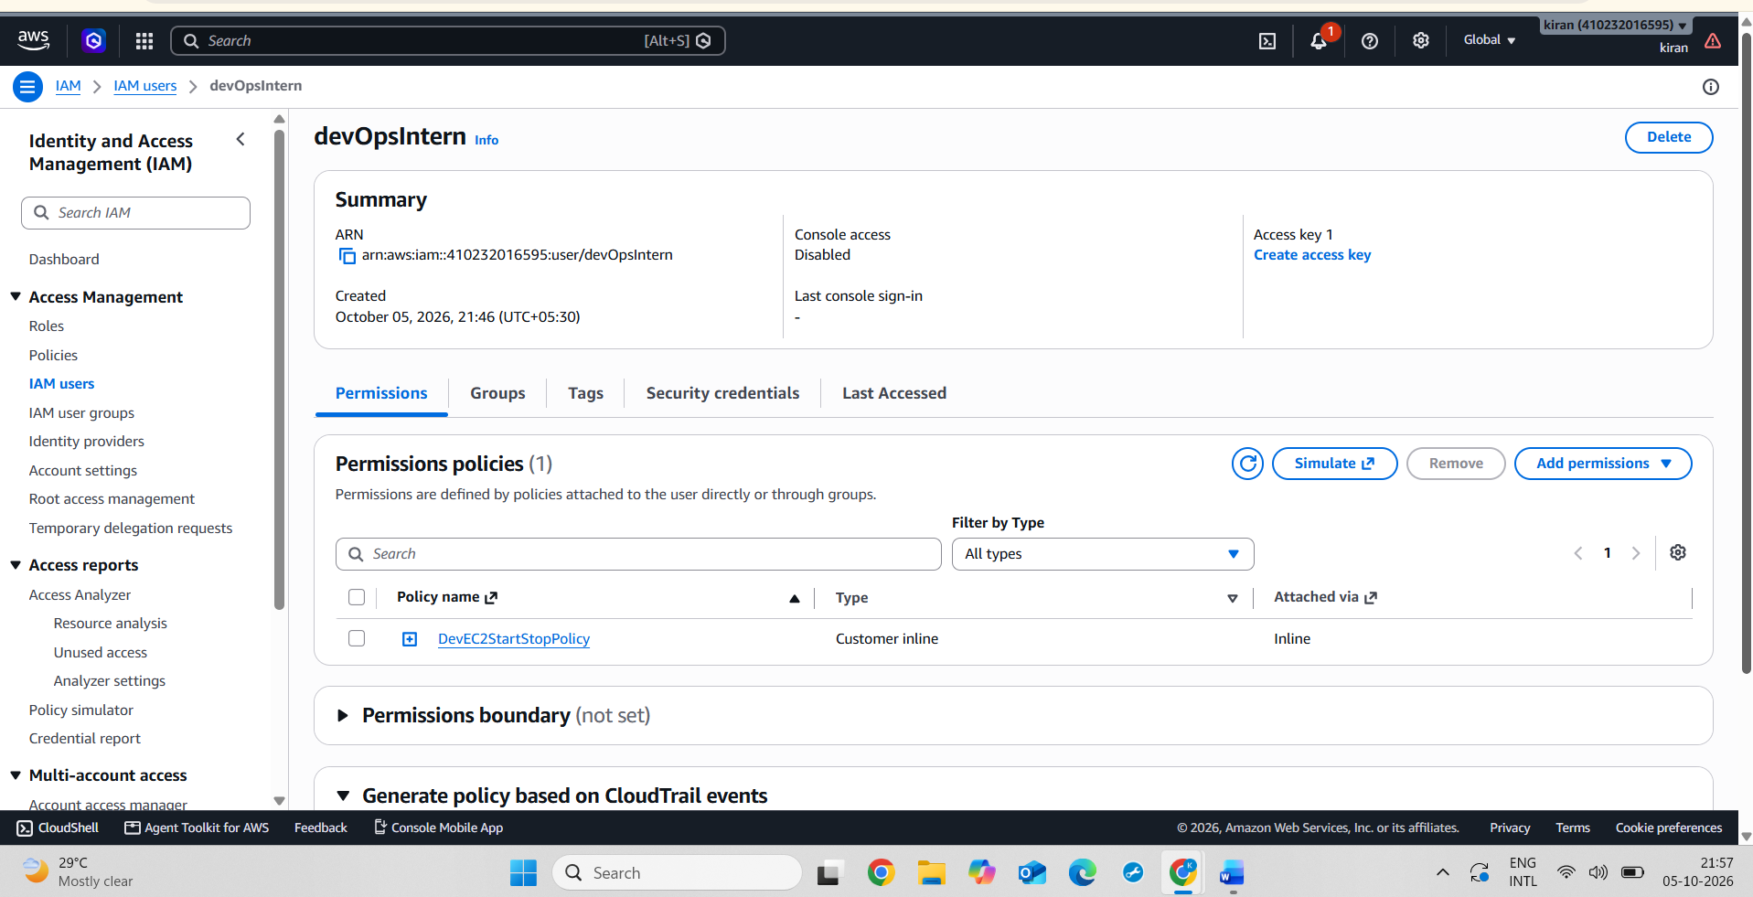
3.
Create a managed policy in AWS IAM that grants permission to list and view DynamoDB tables, then attach this policy to a group called 'appReviewers' which could represent users reviewing app data like Zomato order history.
ANS :
Steps :
- Logged in to the AWS Management Console and opened the IAM service.
- Navigated to IAM → Policies and clicked Create policy.
- Selected the JSON tab and entered a custom policy with read-only DynamoDB permissions such as ListTables, DescribeTable, GetItem, Scan, and Query.
- Named the managed policy DynamoDBAppReviewerReadOnly and created the policy.
- Navigated to IAM → User groups and clicked Create group.
- Created a new group named appReviewers.
- Selected DynamoDBAppReviewerReadOnly from the available policies and attached it to the group.
- Opened the appReviewers group and verified that the managed policy was successfully attached.
Screenshot : Custom managed IAM policy providing read-only permissions to list and view DynamoDB tables and data.
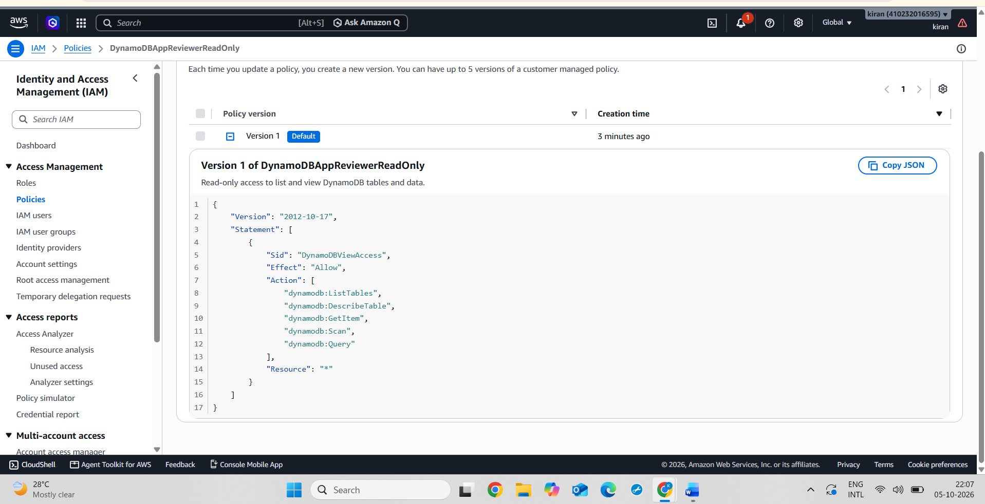
Screenshot : DynamoDBAppReviewerReadOnly managed policy successfully attached to the appReviewers group.
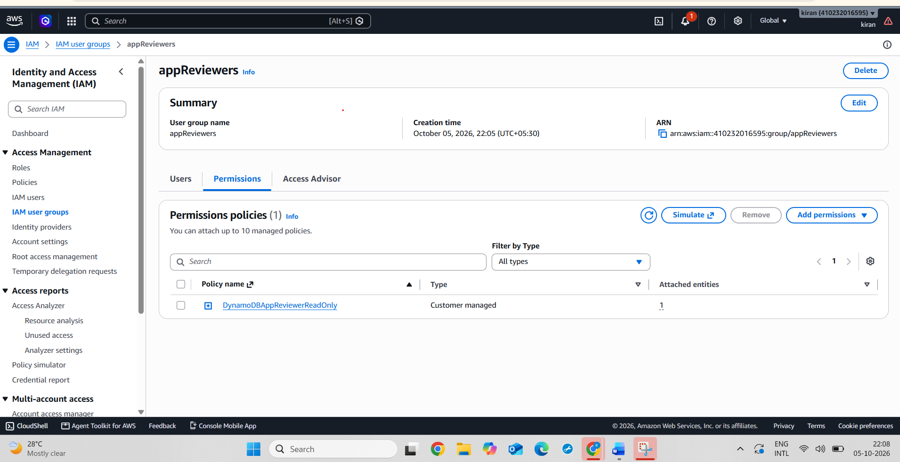
4.
Given the following JSON policy, identify and fix the error that would prevent it from granting access as intended: <br><br> { "Version": "2012-10-17", "Statement": [ { "Effect": "Allow", "Action": "s3:GetObject", "Resource": "arn:aws:s3:::user-uploads/*" } ] } <br><br><em><strong>Hint:</strong> Check if the policy allows listing the bucket as well as getting objects.</em>
ANS :
The given IAM policy allows the user to read objects from the user-uploads S3 bucket using s3:GetObject, but it does not allow the user to list the contents of the bucket.
The error is fixed by adding the s3:ListBucket permission. The s3:ListBucket action must use the bucket ARN without /*, while s3:GetObject uses the object ARN with /*.
Corrected JSON Policy:
{
"Version": "2012-10-17",
"Statement": [
{
"Effect": "Allow",
"Action": "s3:ListBucket",
"Resource": "arn:aws:s3:::user-uploads"
},
{
"Effect": "Allow",
"Action": "s3:GetObject",
"Resource": "arn:aws:s3:::user-uploads/*"
}
]
}
Result: The corrected policy allows the user to list the user-uploads bucket and read/get objects stored inside it.
5.
Use ChatGPT to generate a JSON IAM policy that allows users to only update their own profile information in a DynamoDB table named 'UserProfiles', then review and test the policy in the AWS Policy Simulator.<br><br><em><strong>Hint:</strong> Ask ChatGPT for a policy with a condition that enforces users can update only their own data.</em>
ANS :

Steps :
- Logged in to the AWS Management Console and opened the DynamoDB service.
- Created a DynamoDB table named UserProfiles with UserId as the partition key.
- Opened the IAM service and created an IAM user named use_r.
- Created a new IAM policy named UserProfilesOwnUpdatePolicy.
- Created a JSON policy that allows the dynamodb:UpdateItem action on the UserProfiles table.
- Added the dynamodb:LeadingKeys condition with ${aws:username} to ensure that the user can update only the DynamoDB item whose UserId matches their IAM username.
Used the following policy structure:
{
"Version": "2012-10-17",
"Statement": [
{
"Sid": "UpdateOwnProfileOnly",
"Effect": "Allow",
"Action": "dynamodb:UpdateItem",
"Resource": "arn:aws:dynamodb:ap-south-1:ACCOUNT_ID:table/UserProfiles",
"Condition": {
"ForAllValues:StringEquals": {
"dynamodb:LeadingKeys": [
"${aws:username}"
]
}
}
}
]
}

8.Attached UserProfilesOwnUpdatePolicy to the IAM user use_r.
9.Opened the IAM Policy Simulator and selected the IAM user use_r.
10.Selected DynamoDB → UpdateItem and specified the UserProfiles table as the resource.
10.Ran the policy simulation.
11.The simulation returned Allowed, confirming that the policy permits the user to perform the UpdateItem operation on the specified resource.
Screenshot : UserProfiles DynamoDB table with UserId as the partition key.
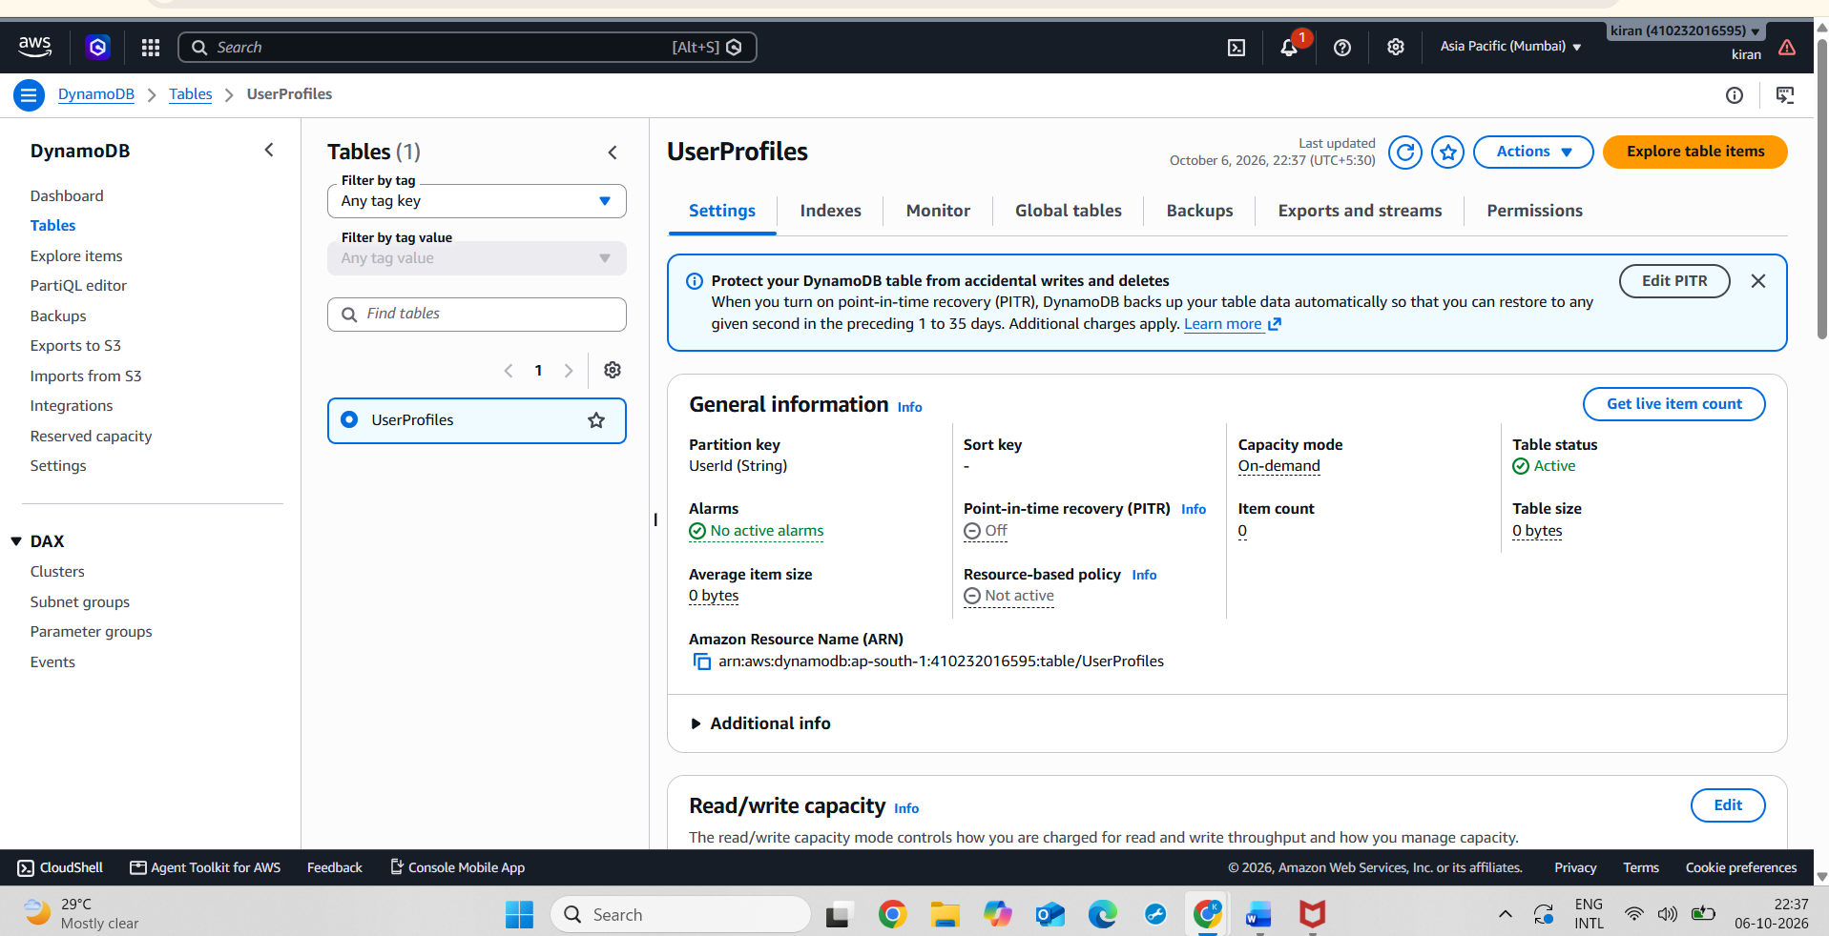
Screenshot : IAM policy restricting users to update only their own UserProfiles record using the ${aws:username} condition.
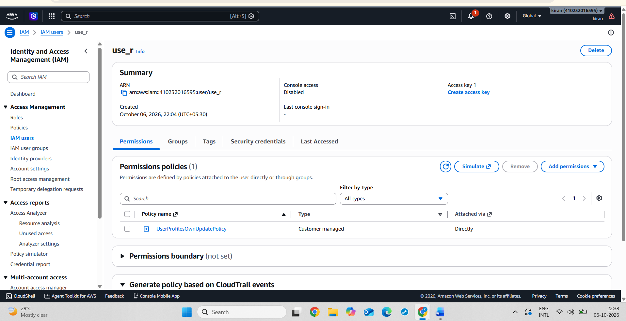
Screenshot : IAM Policy Simulator showing that user use_r is allowed to perform DynamoDB UpdateItem on the UserProfiles table.
